**TAIT TIGER NEWS**

**Newsletter #6 January 28th, 2022**

**Telephone: 604-668-6444 Principal: Mr. Rusty Mason**

**Student Absences: 604-668-6444 Admin. Assistant: Ms. L. Rutsch**

**Website address:** tait.sd38.bc.ca **Area Superintendent: Ms. C. Brautigam**

**Email:** [tait@sd38.bc.ca](mailto:tait@sd38.bc.ca) **Trustee: Mr. Norman Goldstein**



**From the Office**

**We Are Planning For September 2022**

Kindergarten Registrations.

If you have a child turning five in 2022, please register them at the Board Office right away for Kindergarten. The school District is now into the Priority 2 Round of Registration. Students registered in the Priority 2 Round are accepted to their neighborhood school only after Priority 1 Round students have been accepted and if there is space in the school. If you know someone living in the Tait catchment with a Kindergarten aged child, please encourage them to register now.

School Transfer Application from February 7th to February 25th

The School Transfer Round 1 opens on Monday February 7th, 2022. If you plan to register your child at a school that is not your neighborhood catchment school, you must do so from February 7th to 25th for the best chance of getting into that school. Registering for a transfer during this time period does not guarantee you a spot. Decisions on acceptance to a school as a transfer applicant are based upon a variety of factors, including reason for a transfer and available space in that school. For students moving from Grade 7 to 8 and wishing for a transfer to a non-catchment high school, this is the period of time for your best chance of being successful for transfer approval. Decisions on Transfer Applications will be made by Monday March 7th, 2022.

Being on Time for School Shows Caring for your Classmates and Teacher!

**During this time of Covid19, we require students to arrive at school on time between 8:40 and 8:45am**.

When students arrive at school there are many tasks for the students and their teacher to complete:

* checking in to make sure the student is feeling well
* hanging up a jacket and backpack
* hand washing
* handing in homework or checking student planners
* collecting notices
* starting morning learning activities

If students arrive late (after 8:45), class will already be started. Students arriving late will need to do all the same tasks before they are permitted to take their seat and start the day. Some of these tasks require teacher assistance - as a result the teacher will need to stop instruction and support the late student. When this occurs, teacher instruction for all other students is halted and this affects the learning of everyone in the class.

We need all students at school by 8:40 a.m. so they can take care of all the necessary tasks before they start the day. Parents, we ask for your help in this matter. Do your best to leave your home earlier. Arriving on time is an important part of developing social responsibility. Please help your children develop this important skill. The school office will keep track of students arriving late over the next month. Thank-you for your help.

**Covid19 and Flu and Cold Season**

Covid19 continues and it is also flu and cold season. Staff and students are being reminded to wash their hands regularly, be aware of another person’s personal space, and to use the Mandatory Daily Health Declaration (included as an additional attachment in this email) every morning before coming to school.

If a staff member or your child is ill, they cannot come to school.

The Winter months always have the highest number of student and staff absences, primarily due to illness. We can work together to minimize the number of students and staff who are ill if we remember some very simple guidelines and strategies.

• DO NOT send students to school who have any of the following symptoms:

Fever or chills Sore throat Headache

Cough Loss of appetite Body aches

Loss of sense of smell or taste Runny nose Nausea or vomiting

Difficulty Breathing Sneezing Diarrhea

Extreme fatigue or tiredness

• If a student has a fever, it is recommended they seek medical advice from a Health Practitioner before returning to school.



• Have your child go to sleep at a time that gives them at least 10 hours of sleep. When our bodies are tired and ‘run down’ we are far more susceptible to illness.

Thank-you for your help to keep everyone at Tait Elementary healthy through the Winter months.

**Student Absences**

If your child will be absent from school, please call the school directly at 604-668-6444 to speak to our office staff or leave a message. Please do not rely on an email to your child’s classroom teacher telling them about your child’s absence. Classroom teachers may not have the chance to access their email before school, and may mark your child as absent with an unknown reason as to why they are missing from school. If classroom teachers enter a child as absent without a reason, our office staff will make a phone call home to parents to find out the whereabouts of a child. This procedure can be aggravating for parents, and takes valuable time from our office staff that could be better used.

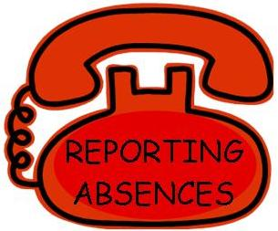

Thank-you for your understanding. Please call 604-668-6444 if your child will be absent from school.

**Early Dismissal Wednesday, February 16th at 1:45pm for Parent Teacher Conferences** 

On Wednesday, February 16th, 2022, all students will be dismissed from school at 1:45pm for Parent Teacher Conferences.

This year, we will have two early dismissal dates in Term 2: Wed. Feb. 16th and Wed. Mar. 9th. On both Early Dismissal days, students will be dismissed at 1:45pm (one hour early).

Why are there two Early Dismissals, you might ask? The reason is because we have two different Student Reporting Formats in the school – one using online student e-Portfolios (Div’s 1, 2, 3, 6, 7, 8, 9), and the other using Traditional ‘paper’ Student Reports (Div’s 4 and 5)

These two different Student Reporting Formats occur at different times in Term 2: e-Portfolios on February 11th and Traditional Student Reports on March 10th.

Please mark in your calendar, all students will be dismissed at 1:45pm on Wednesday, February 16th, and again on Wednesday, March 9th at 1:45pm

**Electronic Devices Can Affect A Child’s Sleeping Patterns**

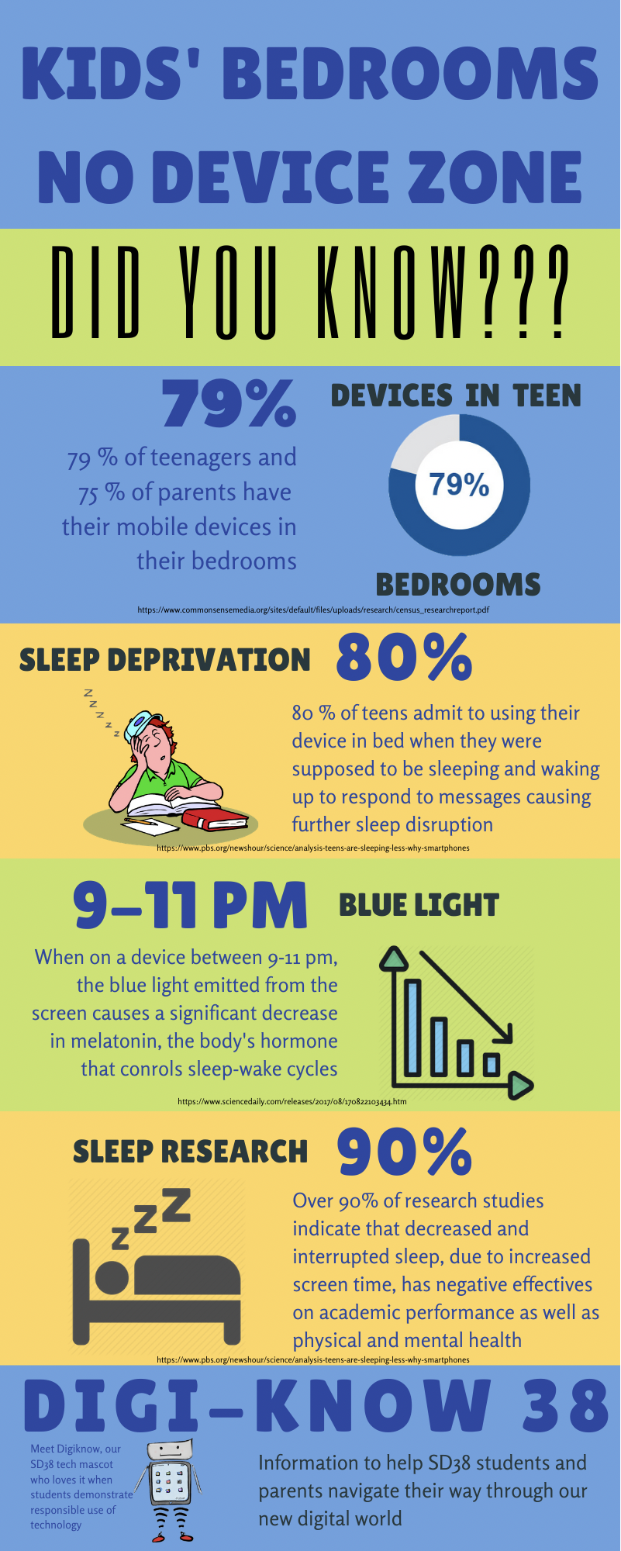Children need a good night’s sleep. How a child sleeps through the night affects their mood, energy level and behaviour, along with their overall health. Pediatricians recommend at least 10 hours of uninterrupted sleep each night for a school-aged child. At night, their body and brain need to rest and recover to get ready for the next day. Unfortunately, at school, we see many of our students coming to school tired and not at their peak level for the learning they will do throughout a day. When we ask the students why they are tired, many times they say it is because they were on their electronic devices or playing video games late into the evening. Researchers are telling us this problem has some serious consequences to a child’s development and learning. DID YOU KNOW...

**Around the School**

**Upcoming Professional Development Days – Monday, January 31st and Friday, February 18th**

****On Professional Development Days, students do not attend school. Staff at British Columbia schools use ProD Days to learn new instructional strategies and curriculum. Educators apply what they learn during ProD Days to their instructional practice in the classroom, so they can help your child learn better. Thank-you for supporting these learning days for educators. Monday, January 31st and Friday, February 18th are Professional Development Days at Tait Elementary. Students do not come to school on these two days.

**Family Day Holiday Monday, February 21st**

Monday, February 21st is the Family Day holiday. All schools in Richmond and throughout the Province of British Columbia will be closed. School will resume on Tuesday, February 22nd.

**Pink Shirt Day February 23rd – “Say No to Bullying”**

All of our students, staff and parents are encouraged to wear PINK on Wednesday, February 23rd as a stand against bullying. In classes, we will talk about the importance of “Pink Shirt Day”. Building a caring community is our best defense against teasing and bullying.



Caring starts with empathy – recognizing how someone is feeling and connecting with them to let them know that you see and understand how they feel

**PAC News**

The Robert J. Tait Parent Advisory Council is always looking for parent volunteers to help the PAC support students at Tait School. If you have an idea for the Tait P.A.C. please come to the next meeting. All Tait parents are part of the Tait PAC. We encourage you to come to our PAC Meetings to find out more about the school.

**The next PAC meeting will be held on:**

**Monday, January 31st, 2022 at 6:30pm on Zoom.**

**(The Zoom Meeting ID and Password was sent to parents by email on Tuesday, Jan. 25th)**



• Monday, Jan. 31st ProD Day – no school for students

• Monday, Jan. 31st PAC Meeting @ 6:30pm on Zoom

• Thursday, Feb. 10th Hot Lunch Day - Subway

• Monday, Feb. 14th Valentine’s Day

• Wednesday, Feb. 16th Early Dismissal @ 1:45pm for Parent/Teacher Conferences

• Friday, Feb. 18th ProD Day – no school for students

• Monday, Feb. 21st Family Day Holiday

• Wednesday, Feb. 23rd Pink Shirt Day

• Thursday, Feb. 24th Hot Lunch Day – Pizza Hut

• Wednesday, March 9th Early Dismissal @ 1:45pm for Parent/Teacher Conferences

• Thursday, March 10th Hot Lunch Day – Taco Luis

• Friday, March 11th Last Day of Term 2 before Spring Break

• Mar. 14th – 25th Spring Break (School is Closed)

• Monday, March 28th First Day Back after Spring Break